Declarative Sentences

✅ Definition:
# Source: AI Source: Provided by: [Data Path: Persons Table -> ID Column: 1, Name_En Column: Motasem Essam] -> From: [Chatgpt (GPT-4-turbo)] on [7/28/2025]
A declarative sentence is a sentence that makes a statement, gives information, or expresses an idea or opinion.
It is the most common type of sentence in both writing and speech.

🧩 Key Features of Declarative Sentences:
# Source: AI Source: Provided by: [Data Path: Persons Table -> ID Column: 1, Name_En Column: Motasem Essam] -> From: [Chatgpt (GPT-4-turbo)] on [7/28/2025]
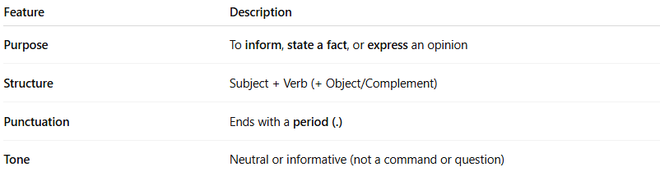
Feature | Description
Purpose | To inform, state a fact, or express an opinion
Structure | Subject + Verb (+ Object/Complement)
Punctuation | Ends with a period (.)
Tone | Neutral or informative (not a command or question)

✏️ Examples:
# Source: AI Source: Provided by: [Data Path: Persons Table -> ID Column: 1, Name_En Column: Motasem Essam] -> From: [Chatgpt (GPT-4-turbo)] on [7/28/2025]
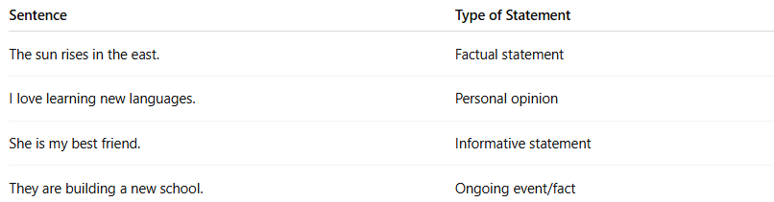
Sentence | Type of Statement
The sun rises in the east. | Factual statement
I love learning new languages. | Personal opinion
She is my best friend. | Informative statement
They are building a new school. | Ongoing event/fact

📌 Types of Declarative Sentences:
# Source: AI Source: Provided by: [Data Path: Persons Table -> ID Column: 1, Name_En Column: Motasem Essam] -> From: [Chatgpt (GPT-4-turbo)] on [7/28/2025]
- Positive (Affirmative) – states something is true
  - Example: He speaks French fluently.
- Negative – states something is not true
  - Example: She does not like coffee.
  - Formed with "not", auxiliary verbs (don’t, didn’t, won’t, etc.)

🔍 Declarative Sentence vs. Other Types
# Source: AI Source: Provided by: [Data Path: Persons Table -> ID Column: 1, Name_En Column: Motasem Essam] -> From: [Chatgpt (GPT-4-turbo)] on [7/28/2025]
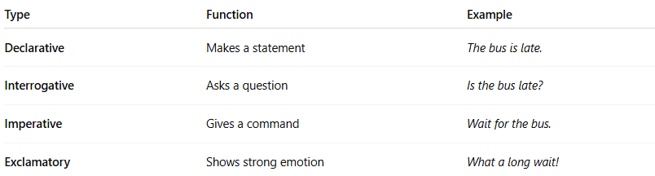
Type | Function | Example
Declarative | Makes a statement | The bus is late.
Interrogative | Asks a question | Is the bus late?
Imperative | Gives a command | Wait for the bus.
Exclamatory | Shows strong emotion | What a long wait!

🧠 Summary:
# Source: AI Source: Provided by: [Data Path: Persons Table -> ID Column: 1, Name_En Column: Motasem Essam] -> From: [Chatgpt (GPT-4-turbo)] on [7/28/2025]
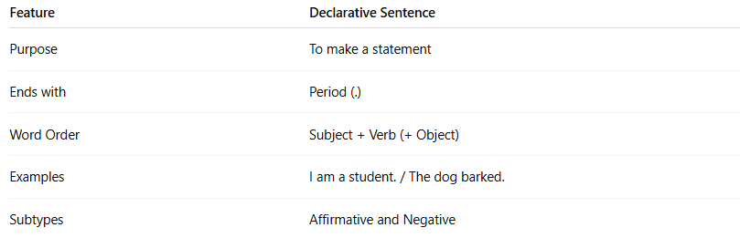
Feature | Declarative Sentence
Purpose | To make a statement
Ends with | Period (.)
Word Order | Subject + Verb (+ Object)
Examples | I am a student. / The dog barked.
Subtypes | Affirmative and Negative

